Linux Architecture
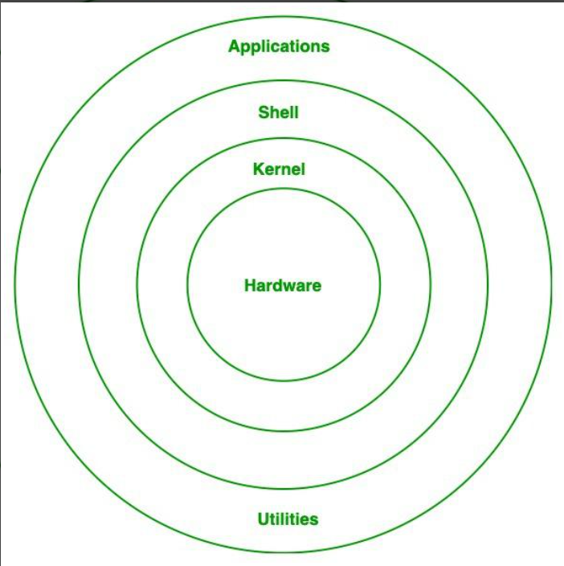
Hardware Layer :
The hardware layer is the lowest level of a Linux system and includes all the physical parts of a computer, such as the CPU, RAM, hard drive or SSD, motherboard, network card, and input/output devices like the keyboard, mouse, and monitor. These are the actual components you can see and touch. This layer itself does not contain any software, but it provides the foundation on which the operating system runs. Linux communicates with this hardware through the kernel and device drivers, which help control and manage how the hardware works. Without the hardware layer, the Linux operating system would not be able to function.

Kernel
The kernel is the core part of the Linux operating system that acts as a bridge between the hardware and the software. It sits between the applications or shell and the computer’s physical components, making sure everything works smoothly. The kernel manages important tasks such as memory management, process scheduling, and device control. It decides which process gets to use the CPU, allocates memory to programs, and handles communication with hardware like disks, printers, and network devices through device drivers. It also ensures system security and prevents programs from interfering with each other. Since the kernel directly interacts with the hardware, it plays a major role in the system’s performance, stability, and overall functioning.
The kernel is responsible for:
- Memory management: Manages and allocates memory efficiently.
- Resource allocation: Distributes system resources to different processes.
- Device management: Controls input/output devices like printers and scanners.
- Process management: Manages process execution and scheduling.
- Application interaction: Bridges applications with system-level functions.
- Security: Provides essential system-level security.

Shell
The shell is the part of Linux that lets users talk to the operating system. It acts like a bridge between the user and the kernel. When you type a command, the shell understands it and sends it to the kernel to perform the task. In simple words, the shell is like a translator that converts user commands into actions the computer can understand. It allows you to run programs, manage files, and control the system using commands. Examples of shells in Linux include Bash, Sh, and Zsh. Without the shell, users would not be able to easily interact with the operating system.
Application
An application is a software program that helps a user perform specific tasks on a computer. It sits on top of the operating system and uses system resources through the kernel to do its work. Applications are the programs we interact with directly in our daily use of a computer. Examples include web browsers like Chrome, text editors like Notepad, media players like VLC, and office tools like MS Word or Excel. In simple terms, an application is any program that is designed for users to do useful work, such as writing, browsing the internet, watching videos, or managing files.

The most powerful and versatile component of Linux operating system is Kernel, using which functional of whole operating system can be controlled. Kernel provides a huge range of functionality, which can be easily accessed by the user in an interactive way using shell. For the proper functionality of the operating system, proper hardware are needed. All the components of the the operating system make it easier, faster, stable and reliable.

User (in Linux)
A user is a person or account that interacts with the Linux system. Users can log in, run applications, create files, and use system resources based on the permissions given to them. Each user has a username and specific access rights to keep the system secure and organized. There are different types of users, such as regular users who perform everyday tasks and the root user (administrator) who has full control over the system. In simple terms, a user is anyone who uses the computer through the operating system.

systemd (in Linux)
systemd is a system and service manager in Linux that is responsible for starting and managing system services when the computer boots. It runs in the background and makes sure essential services like networking, logging, and scheduling are started and kept running properly. systemd also handles tasks such as managing system processes, mounting file systems, and tracking system states. In simple words, systemd is like a manager that starts the system, keeps important services running, and ensures the Linux system works smoothly after it turns on.

